ART SCHEDULING BOOKLET

30-day Expectations and Measurables:

- Orientation and Familiarization: become acquainted with the Art Department’s workflow, team members, and ongoing projects.
- Training and Wrike: Undergo training sessions to gain proficiency in utilizing Wrike to schedule artists’ daily tasks and manage Art Department initiatives.
- Shadowing and Observation: spend time shadowing the Art Manager and Creative Director to understand their roles and responsibilities within the department.
- Initial Project Management Setup: Begin setting up the global Project Management dashboard in Wrike, collaborating with relevant stakeholders to gather necessary information.
- Review Current Processes: Evaluate existing scheduling and project management processes to identify potential areas for improvement or optimization.
- Communication: Establish open lines of communication with team members, clients, and other departments to ensure smooth coordination and collaboration.
- Documentation: Start documenting procedures and best practices for scheduling and project management within the Art Department

60-day Expectations and Measurables:

- Independence in Wrike Usage: Demonstrate proficiency in independently managing artist schedules and updating the Project Management dashboard in Wrike.
- Optimization of Scheduling: Implement any identified improvements to the scheduling process to enhance efficiency and accuracy.
- Project Management Implementation: Ensure that all ongoing Art Department initiatives are accurately tracked and managed within the global Project management dashboard.
- Collaborative Problem-Solving: Actively participate in resolving any scheduling conflicts or project management issues that arise, seeking input from team members and stakeholders as needed.

- Training Support: Provide support and training to any team members who may require assistance with using Wrike or understanding new scheduling procedures.
- Regular Reporting: Establish regular reporting mechanisms for tracking key metrics related to scheduling and project management, providing updates to the Art Manager and Creative Director.
- Continuous Improvement: Continuously solicit feedback from team members and stakeholders to identify further opportunities for process improvement and refinement.

90-day Expectations and Measurables:

- Efficient Workflow Establishment: Implement established processes and procedures for scheduling and project management that ensure the Art department operates smoothly and efficiently.
- Advanced Wrike Utilization: Explore advanced features and functionalities or Wrike to streamline scheduling and project management processes further.
- Quality Assurance: Develop mechanisms for quality assurance to ensure that all scheduled tasks are completed accurately and on time, minimizing errors and delays.
- Resource Allocation Optimization: Fine-tune resource allocation strategies based on insights gained from tracking project performance and workload distribution.
- Cross-Departmental Collaboration: Strengthen collaboration with other departments, particularly Sales and Production, to optimize coordination and alignment of schedules and project priorities.
- Documentation and Training Materials: Finalize documentation and training materials for scheduling and project management processes, ensuring accessibility and clarity for all team members.
- Long-term Planning: Begin participating in long-term planning discussions with the Art Manager and Creative Director, providing insights and recommendations based on observed trends and data analysis.

Standard Operating Procedure Table of Contents

- Breakdown of the day
- Helpful things to remember
- Job priority
- Point of contact list
- Slack channels
- Organizing art email

- Navigation folders in wrike
- Revision needs scheduled
- Needs scheduled
  - 72-hr turnaround
  - Marketing and Art Policy
  - CSI jobs
- Approvals
  - Taking jobs out of approval when the client needs to re-approve
  - Uploading new art when the job is already approved and no client approval is needed
- Consults

IV. Reorders

V. CSI Reporting

Breakdown of the day
8-9am
- Arrive before the team to get the schedule set up and ready to go
- Assign revisions, and rush today jobs (slack artist about rush jobs)
- Balance each artist’s schedule for the day
- Communicating w/Jared when the schedule is updated for the morning “forecast” by 8:45am

9-10am
- Approve art that came in from the night before

3-3:30pm
- Approve all jobs in the art approved folder

EOD wrap up
- Answer any final slack messages
- Organize email
- Assign jobs from needs scheduling to next day artist schedule

Helpful things to remember:

Job priority
3:30 rush today - job needs to be uploaded by 3:30
Rush today - job needs to be uploaded by EOD
Rush tomorrow - job that should be uploaded today but doesn’t have to close until the next day
3:30 rush revision - revision needs to be uploaded before/by 3:30
Rush revision - job that should be uploaded today but doesn’t have to close until the next day
High - close date is within 3-4 days (changes to within the week during the off-season)
Normal - close date is within a week

Rush today - cutoff during busy season 2pm/3pm in the off-season?

Throughout the day:
- Check and organize art email
- Answer slack messages
- Assign incoming rushes/revisions

- Check the artist’s schedule periodically
- Do schedule check-ins in the #artist channel at 12 and 2 pm

Art jobs that go to M only
- Lynn Andrews
- American Heritage Girls (AHG)
- Winshape Camps

Art jobs that go to senior artists only:
- SC jobs
- CSI jobs (M/Erin)

An opp’s lifecycle in Wrike:
- needs scheduling >> revision needs scheduled/uploaded >> approved needs review >> finals

Point of Contact:
Production scheduling: Kenzie Shelton, Nicole Campana Ros
Sales Manager: John Rucker
Separations: Patrick Farley/GraphXsource??
IT: Tyler Redman, Cory Linz
Consults: Mackenzie Luke
CSIs: Oshay Reynolds

Slack channels
#artist - any updates or announcements go here, send the schedule check-in to this channel

#rush-today - jobs that need to be uploaded today get posted here, assign the job to an artist, message artist that there is a rush on their schedule
**reference section: Needs scheduling

#post-art-approval - jobs that need to be resized or edited post-approval get put here - search job, mark status “stop the presses,” then assign back to artist, adjust time and priority if needed
- put in revision on monday production board as well/if the job is staged or job jacket is printed send a message to production scheduling to alert them of the changes
**reference section: Taking jobs out of approval when the client needs to re-approve

How to organize the art email:

Folder/type of email
- Convos (revision notes, asking for files)

- Files for consults
- Convos with consultant (convos with client and Mackenzie)
- Calendly (calendly automated emails)
- Surveys (Form assembly surveys)

**SOP from Consults:
Current SOPS for email: Art coordinator is in charge of keeping the art email in order and organizing it. This means the art coordinator is in charge of responding to clients/ P.A.s who send emails to art@sundaycool.com and putting emails in the correct folder they belong in.
- All emails that are for/have files for consults go into the “files for consultations”
- All emails that address the current Art consult or is in an ongoing conversation with the art consult goes into the “convos with consultant” folder
- All Calendly notification emails go into the “calendly” folder
- All emails that are between the Art coordinator and the PA/client go into the “CONVOS” folder
Overall, Art consult should check the email first thing in the morning to see if a client has emailed them specifically and will be checking it through out the day for files for consults/ specific emails from clients. Art coordinator Should be checking through out the day

Navigating Folders in Wrike

Revision Needs Scheduled
- Review revision comments, assign time (art revision estimate) to complete the revision, update revision priority and date if needed
- Assign jobs back to the artist (status and location should change automatically)
- If a job needs a new file or does not have revision comments, mark the status as “in revision - waiting on PA” and reach out to PA directly with what you need
- If a job looks like it needs a consult, reach out to PA to send the client the consult link and change the status to “consult”
- If a job has attachments….upload to wrike in comments section and tag artist
- If the job is a rush, message artist with opp number and rush today or rush revision (ex.234064 rush revision)

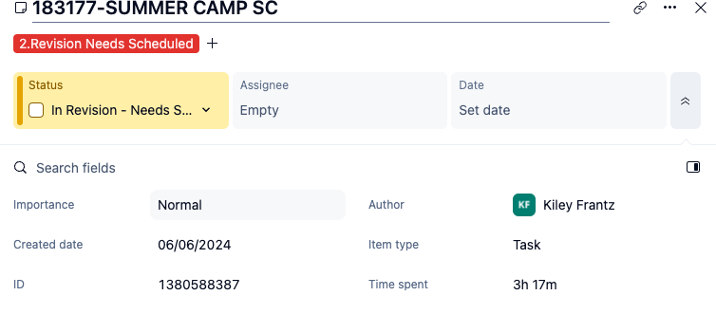
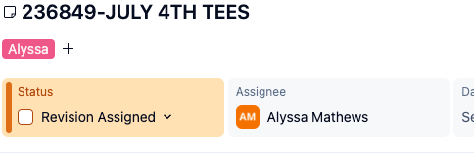

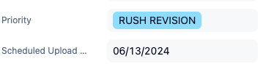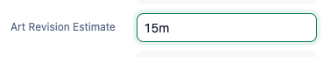

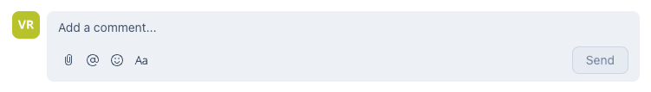

Needs Scheduling
- Read arf
- Assign a date and time (scheduled upload date) to complete the job (initial art estimate)
- Change status to art assigned
- You can then leave the job in art assigned and put on an artist’s schedule at EOD or while you are reviewing the job
- Put the artist’s name in the assignee box and the location should change on its own
- schedule within the 72-hour window
  - When a new job is created and populated in Wrike, the 72-hour countdown begins immediately.
  - The job is scheduled for the next business day following its creation.
    - Example: If a job is created on 1/17, it will be scheduled as a "normal" priority for 1/18.
- By the second day, the job is escalated to a "high" priority status and must be completed and uploaded by the end of the 72-hour window.
- Example: A job created on 1/17 must be uploaded by 1/19.
If a job cannot be completed within the 72-hour window, it becomes a “rush today” priority.
- CSI jobs that come through the schedule get assigned to M or Erin only
Marketing Policy
- Turnaround Time:
  - Adhere to a standard 72-hour turnaround time for all projects unless team capacity constraints prevent meeting this timeline.
- Close Dates:
  - Ensure all close dates are accurate, up-to-date, and aligned with the designated print date.
- Rush Requests:
  - The art team reserves the right to decline rush requests if team capacity does not permit their completion without compromising quality or other priorities.
- Request Submission:
  - All project requests must be submitted through Ronnie and M. to ensure proper tracking and prioritization.

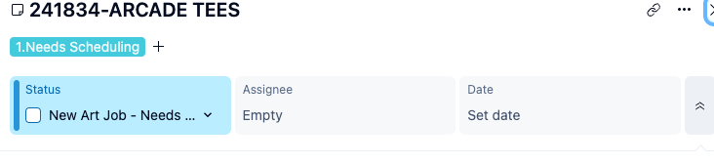

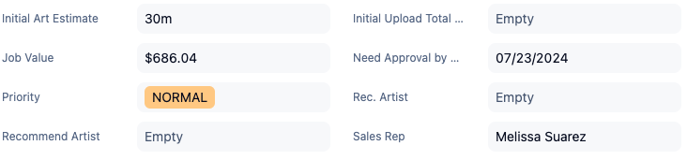

Uploaded Folder
- Scrub folder checking for any jobs with comments on them
- Assign the revisions as you would normally (there is no automation from this folder to artist schedules)
  - Assign date, priority, time for revision, status, location and assignee

Approved Needs Review
- Review proof to check for correct sizing, garment type, correct number of inks and screens
- Rename the file to _final
- Change status from “art approval” to “reviewed->SF/DB”
- Location should change to final automatically
- Check dropbox link to make sure the final proof was uploaded

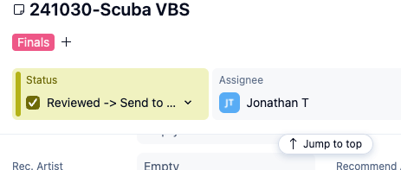
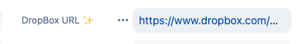
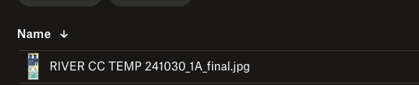
Taking jobs out of approval when the client needs to re-approve
- Mark the status as “stop the presses”, then mark the status “revision assigned”
- Mark assignee to artist
- Mark job in revision on monday board

Uploading new art when the job is already approved and no client approval is needed
- Download new proof
- Delete proof in dropbox, refresh page and make sure old one is gone
- upload new proof
- Rename “final”
- Copy link and update final art link in Salesforce
- Notify seps and production scheduling that a proof was updated

Consult Jobs
- Reading arfs it should note it is a consult
- Change the status to “consult”
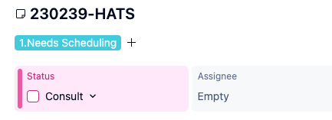

Reorders

If a reorder needs to be revised it should be put into wrike, but
- If reorders are not put into wrike and needs to be revised
- Slack artist with revision notes and opp number
- Have artist send a new mockup through slack
- Re-upload proof to Dropbox, update link in SF (same steps as uploading a new proof after approval)

CSI Reporting

Check CSI dashboard on Salesforce (https://sundaycool.lightning.force.com/lightning/r/Dashboard/01Z4w000001MJriEAG/view?queryScope=userFolders)

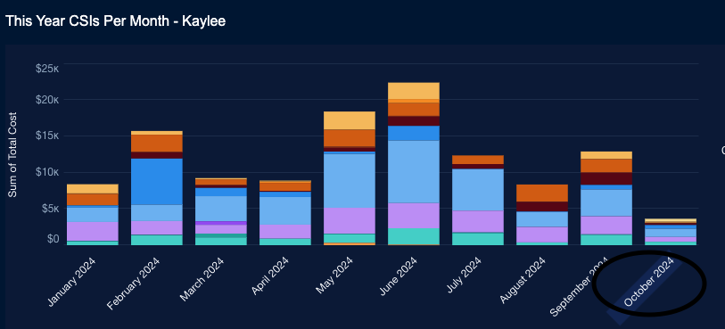

Go to the art department section
To see info about a particular CSI click on the case number

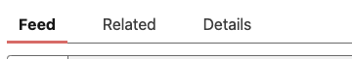

The “related” and “details” sections will have the info needed (reason/cost, etc…)

Communicate info with the art manager in case the issue needs to be addressed with the team

